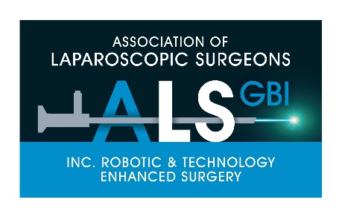
ALSGBI Laparoscopic Passport Training & Assessment Course
7th February 2020
Programme
Venue: Skills Centre, The Royal College of Surgeons of Edinburgh

10.00- 10.15 Registration
10.15-10.30 Introduction
10.30 - 11.30 Task 1: Polomint Manipulation
Task competency time 4 mins
11.30 - 1300 Task 2: Extracorporeal knots + ‘Appendicectomy’
Task competency time 8 mins
1300 – 13.30 Lunch
13.30 – 14.15 Task 3: Precision Cutting
Task competency time 3 mins
14.15-14.30 Coffee break
14.30 – 16.20 Task 4: Laparoscopic Suturing
Task competency time 6 mins
16.20 – 16.50 Procedural Skills: Appendicectomy, Cholecystectomy, Patch closure DU
16.50 - 17.00 Close of Day

ALSGBI Awarded 4 Hrs of CPD

