18th Laparoscopic Inguinal Hernia Repair Workshop
20th & 21st February 2020

Bassetlaw Hospital, Kilton, Worksop S81 0BD

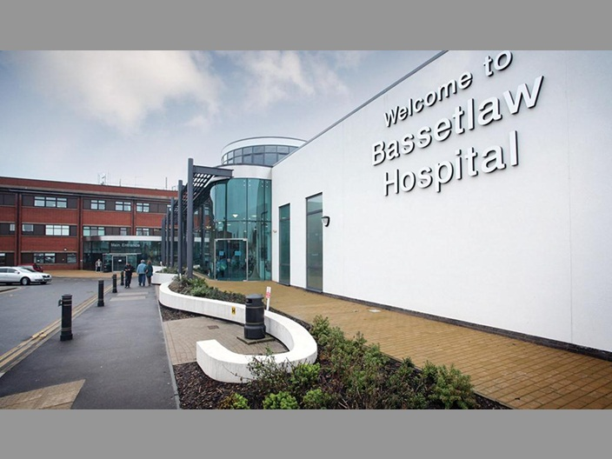

Free registration!!*
TAPP & TEP repairs
Live demonstration
Hands-on operating#
Interactive teaching in an informal atmosphere

Course Director- Mr S Balchandra

Faculty- Mr A B Harikrishnan
Miss A Durham-Hall

This is a 2 day intensive course aimed at senior trainees and junior consultants with a degree of experience in “open” hernia & Laparoscopic surgery e.g. laparoscopic cholecystectomy, appendicectomy

Course objectives –

- Demonstrate “live” Laparoscopic inguinal hernia repair, TAPP & TEP
- “Hands on” operating under supervision of Faculty#
- Accelerate learning curve in laparoscopic hernia repair
- Emphasis on safe, cost effective and durable techniques
- Personal, detailed & constructive feedback on technique with “tips &tricks”

Topics for discussion

Laparoscopic anatomy of the groin
Patient selection and choice of operation
Technical aspects of TAPP & TEP
Guidelines & up to date evidence
Complications and safety

Limited places

To book
Please send application form & *Administration charge of £120 payable to “Doncaster & Bassetlaw Hospital NHS Trust Charitable fund DR125” to Caroline Sowerby, secretary to Mr Srinivasan Balchandra, Doncaster Royal Infirmary, Armthorpe road, Doncaster DN2 5LT

Candidates not employed by Doncaster & Bassetlaw Hospitals NHS Foundation Trust will need to return the completed occupational health questionnaire, necessary documents (listed on application form) for OH clearance and sign an Honorary contract with the Trust

# Subject to satisfactory occupational health clearance and faculty approval.

Programme

Day1

Session 1- Board room

08:00- 08:15 Registration & coffee (Board room)
08:15-09:00 Laparoscopic Anatomy of the Groin

Session 2- Theatre 3&4

09:00-10:30 Live Demonstration- TAPP and TEP
10:30-17:00 “Hands on” – TEP/ TAPP repair (+ Working Lunch)

Day 2

Session 1- Board room

08:00-08:30 Technical considerations & patient selection
08:30-09:00 Clinical Guidelines & Evidence base

Session 2- Theatre 3&4

09:00-1700 “Hands on” – TEP/ TAPP repair (+ Working Lunch)

1700-1730 Discussion/ Feedback

For enquires

Contact -Mr S Balchandra, Consultant Upper GI & Bariatric Surgeon, Doncaster & Bassetlaw Hospitals NHS Foundation Trust
email: Srinivasan.Balchandra@nhs.net

