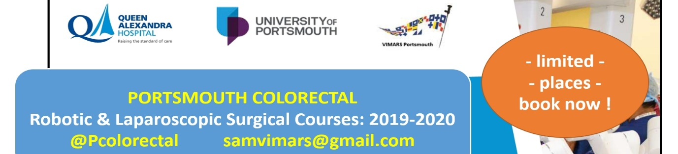

REGISTRATION FORM
TITLE, NAME:
JOB TITLE:
HOSPITAL ADDRESS:
PREFERRED EMAIL ADDRESS:
PHONE NUMBER:
REGISTRATION INFORMATION (please delete as appropriate):
I WOULD LIKE TO ATTEND:
- Robotic & Lap TME Masterclass: YES, NO
12-13th September 2019, Queen Alexandra Hospital, £500

- BASIC ROBOTIC SKILLS COURSE: YES, NO
26th October 2019, Queen Alexandra Hospital, £300

- LAPAROSCOPIC SUTURING&STAPLING COURSE: YES, NO
1st November 2019, Queen Alexandra Hospital & VIMARS, £200

- Robotic CME Masterclass: YES, NO
17-18th January 2020, Queen Alexandra Hospital, £400

- RTTT – Robotic Train the Trainer Course: YES, NO
9-10th February 2020, Queen Alexandra Hospital & VIMARS, fees: TBA

PLEASE PROCEED FOR PAYMENT IN ORDER TO SECURE A PLACE !
After PAYMENT, please email at samvimars@gmail.com a SCREENSHOT of the payment confirmation and your name will be added on the participants list for the course(s) of choice.
Account Name: MART Ltd Barclays Bank name: Barclays
Sort code: 20-11-43, Account number: 83440141
Reference: COURSE NUMBER (1,2,3,4,5 as above) AND YOUR NAME
IBAN: GB88 BUKB 20114383440141
Swift ID: BARCGB22

Please return this registration form to samvimars@gmail.com Thank you!

